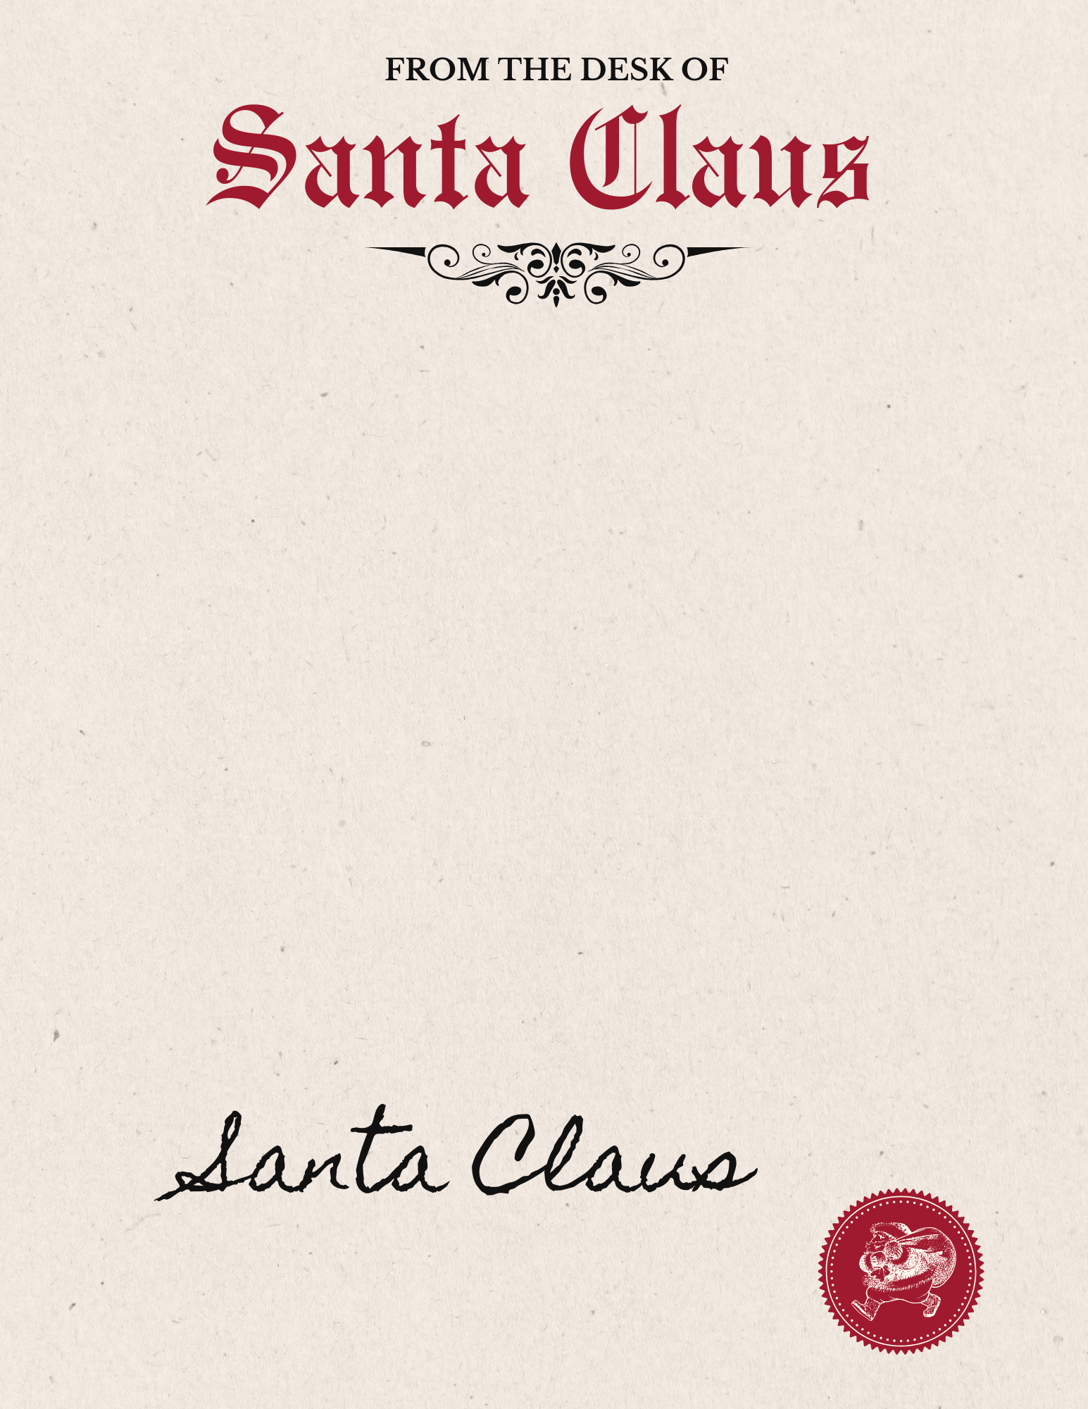

Yours truly,

Dear INSERT NAME OF CHILD,

Thank you for sending me your Christmas letter recently. I read it with great joy!

It's time to get excited, because Christmas is almost here! We are very busy here at the North Pole preparing for the big day. The elves and I have been up late every night making lots of toys here in the workshop for the good boys and girls all over the world.

This year is going to be a great one because we have a lot of new toys that we haven't made before. If you've been well behaved this year, you can expect something special from me.

I hope you're having a wonderful time with your family and friends this holiday season!

P.S. Don't forget to leave a little treat out for the reindeer and I on Christmas Eve.